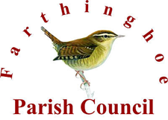

FARTHINGHOE AND STEANE PARISH COUNCIL ELECTION
1 MAY 2025
There will be local council elections on 1 May 2025. All seats on Farthinghoe Council are up for election. Can you give back some time to benefit the villages?

What do the Parish Council do?
- They set and spend the precept for the village.
- They maintain your street lighting.
- They cut the grass.
- The clean and maintain the bus shelters.
- The empty the dog waste bin.
- They provide the village newsletter.
- They comment on all local planning matters.
- They lobby your MP and WNC councillors.
- The seek to protect village assets.
- And a lot of other things as well……………………….

To get an application pack to become a councillor please visit:
Local elections 2025 | West Northamptonshire Council
